Oxford Resources for IB

Chemistry – 2023 Edition

Answers to practice problems

Structure 1—Models of the particulate nature of matter
1.1 Introduction to the particulate nature of matter

  - Simple distillation. When the mixture is heated, water will evaporate, then condense in the condenser and flow into the receiver while sodium chloride will remain in the distillation flask. Notice that “evaporation” is not the correct method, as it will allow us to collect only the solid component (sodium chloride) while the liquid component (water) will be lost.
  - Fractional distillation. The two liquids (water and ethanoic acid) boil at different temperatures, so they can be collected in separate receivers.
  - Dissolution in water, then filtration, then evaporation. When the mixture is stirred with water, only sodium chloride will dissolve. The undissolved rock grains can be collected by filtration, washed with water and dried to constant mass. The water from the remaining solution can be evaporated, leaving crystals of sodium chloride.
- $2HNO_{3}\left(aq\right)+Ca{OH}_{2}\left(s\right)→Ca{〖{(NO〗}_{3})}_{2}\left(aq\right)+2H_{2}O$ Notice that calcium hydroxide is sparingly soluble in water, so its state can be either (s) or (aq). If anhydrous (water-free) nitric acid is used, its state will be (l) instead of (aq).
- C
1.2 The nuclear atom
- C
- ${13 \atop 6}$C

  - $0.69×63+0.31×65=63.62≈64$
  - Cu
- Many characteristics of isolated atoms, such as the density of their electron clouds or their ability to interact with other atoms, are spherically symmetrical, and they change steeply at a certain distance from the nucleus, so it is logical to represent the atom as a ball or sphere with a radius equal to that distance. In addition, atoms are quantum objects with no definite shapes or sizes, which justifies the use of simplest geometric figures (balls or spheres) for their visualization. Finally, it is difficult to draw or display an object without a surface while a sphere can be easily represented on paper or computer screen.

1.3 Electron configurations
- C

  - Ga: 1s²2s²2p⁶3s²3p⁶3d¹⁰4s²4p¹
P³⁻: 1s²2s²2p⁶3s²3p⁶
V²⁺: 1s²2s²2p⁶3s²3p⁶3d³
  - [Ar]3d³
  - F:
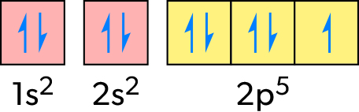
Ni²⁺:
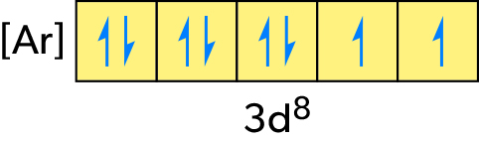

In both cases, full or condensed electron diagrams are acceptable.
- B

1.4 The mole concept
- Each formula unit of Ca(NO₃)₂ contains three ions, so the total amount of ions will be 3 × 0.25 = 0.75 mol, and the number of ions will be 6.02 × 10²³ mol⁻¹ × 0.75 mol ≈ 4.5 × 10²³.
- M(CH₂O) = 12.01 + 2 × 1.01 + 16.00 = 30.03 g mol⁻¹, which is half the molar mass. Therefore, one molecule of compound X contains twice as many atoms as its empirical formula, so the molecular formula of X is C₂H₄O₂.
- CnHm + (n + 0.25m)O₂ → nCO₂ + 0.5mH₂O
$$n\left(C\right)=n\left({CO}_{2}\right)=\frac{1.75g}{44.01g{ mol}^{-1}}≈0.0398 mol$$
$$n\left(H\right)=2×n\left(H_{2}O\right)=2×\frac{0.836 g}{18.02 g{ mol}^{-1}}≈0.0928 mol$$
$\frac{n\left(C\right)}{n\left(H\right)}=\frac{0.0398 mol}{0.0928 mol}≈\frac{3}{7}$, so the empirical formula of Y is C₃H₇.
M(C₃H₇) = 3 × 12.01 + 7 × 1.01 = 43.10 g mol⁻¹, which is half the molar mass of Y. Therefore, the molecular formula of Y is C₆H₁₄.
- M(NaCl) = 22.99 + 35.45 = 58.44 g mol⁻¹
$$n\left(NaCl\right)=\frac{0.117 g}{58.44 g{ mol}^{-1}}≈0.00200 mol$$
$$c_{molar}\left(NaCl\right)=\frac{0.00200 mol}{0.0250 {dm}^{3}}≈0.0800 mol {dm}^{-3}$$
$$c_{mass}\left(NaCl\right)=\frac{0.117 g}{0.0250 {dm}^{-3}}=4.68 g {dm}^{-3}$$

- $n(NaO_3 )=(1.70 g)/(85.00 g〖 mol〗^(-1) )≈0.0200 mol$
$$c(NaO_3 )=(0.00200 mol)/(0.100 〖dm〗^3 )≈0.200 mol 〖dm〗^(-3)$$
Therefore, the correct answer is C.
- V(Cl₂) = 0.5 × V(ClO₂) = 0.5 × 3.00 dm³ = 1.50 dm³
V(O₂) = V(ClO₂) = 3.00 dm³

1.5 Ideal gases
- For answer, see IB Prepared Chemistry Student Book:
  - page 19
  - page 20.
- According to section 1 of the data booklet, pV = nRT, so:
$$V=nRT/p=(0.350 mol×8.31 J K^(-1) 〖mol〗^(-1)×299 K)/(1.15×10^5 Pa)≈7.56×10^(-3) m^3=7.56 〖dm〗^3$$
Notice that the temperature conversion from °C to K: T = 26.0 + 273 = 299 K.
- By definition, $V_m=V/n.$ According to the ideal gas equation, $V/n=RT/p,$ so:
$$V_m=(8.31 J K^(-1) 〖mol〗^(-1)×298 K)/(1.00×10^5 Pa)≈0.0248 m^3 〖mol〗^(-1)=24.8〖 dm〗^3 〖mol〗^(-1)$$
Alternatively, the molar volume can be determined from the V_{m} value at 273 K given in the data booklet (22.7 dm³ mol⁻¹) using Charles's law (V ∝ T):
$$V_m=(22.7 〖 dm〗^3 〖mol〗^(-1)×298 K)/(273 K)≈24.8 〖 dm〗^3 〖mol〗^(-1)$$
- According to section 1 of the data booklet, pV = nRT.
Need to give pressure in Pa and volume in m³, so:
  - $n=pV/RT=(101×10^3 Pa×3.41×10^(-3) m^3)/(8.31 J〖 K〗^(-1) 〖mol〗^(-1)×296 K)≈0.140 mol$
$$M=m/n=(4.35 g)/(0.140 mol)≈31.1 g〖 mol〗^(-1)$$
Therefore, compound X does not contain oxygen, as otherwise the sum of atomic masses of C, N and O atoms would be greater than the molecular mass of the compound.
  - C_{x}H_{y}N_{z} + (x + 0.25y)O₂ → xCO₂ + 0.5yH₂O + 0.5zN₂
$$n(C)=n(CO_2 )=(3.18 dm^3)/(22.7 〖dm^3 mol〗^(-1) )≈0.140 mol$$
$$n(H)=2×n(H_2 O)=2×(6.31 g)/(18.02 g〖 mol〗^(-1) )≈0.700 mol$$
$$n(N)=2×n(N_2 )=2×(1.59 dm^3)/(22.7 〖dm^3 mol〗^(-1) )≈0.140 mol$$
C : H : N = 0.140 : 0.700 : 0.140 = 1 : 5 : 1, so the empirical formula of X is CH₅N.
  - M(CH₅N) = 12.01 + 5 × 1.01 + 14.01 = 31.07 ≈ 31.1 g mol⁻¹, so the molecular formula of X is the same as its empirical formula, CH₅N. Notice that the only organic compound with this molecular formula is methylamine, CH₃NH₂.

Structure 2—Models of bonding and structure

2.1 The ionic model
- Al₂O₃

  - sodium hydride
  - barium hydroxide
  - sodium nitrate
  - calcium fluoride
  - aluminium chloride
  - ammonium phosphate

  - (NH₄)₂CO₃
  - K₂O
  - NaHCO₃
  - BeO
  - CaBr₂
  - MgI₂
- In the solid state, the ions are held in fixed positions by ionic bonding, so they cannot move and therefore cannot carry electric charge. In the liquid (molten) state, the ions can move and it is the ions that act as charge carriers.
- To separate an ionic lattice into individual ions, strong ionic bonds must be broken. This process requires energy, which can be compensated by forming ion–dipole and, in some cases, hydrogen bonds between the ions and solvent molecules. Such bonds can be formed only by polar solvents, such as water. Non-polar solvents can interact with ions only by weak London dispersion forces, the energy of which is insufficient for breaking the ionic lattice.

2.2 The covalent model
- PH₃: Δχ = 0, so non-polar covalent.
HCl: Δχ = 1.0, so polar covalent.
MgF₂: Δχ = 2.7, so ionic.
- A
- C

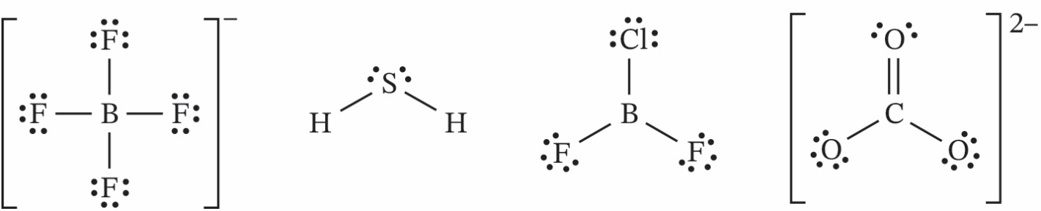
    - tetrahedral tetrahedral trigonal planar trigonal planar
    - tetrahedral bent (V-shaped) trigonal planar trigonal planar
    - 109.5° < 109.5° ≈ 120° 120°
  - Both are polar. In H₂S, the dipoles of H–S bonds are positioned at an angle to each other, and they are not cancelled by the dipoles of lone electron pairs. In BF₂Cl, the dipoles of B–F and B–Cl bonds have different magnitudes (because both the electronegativities and the atomic radii of F and Cl are different), so they also do not cancel one another.

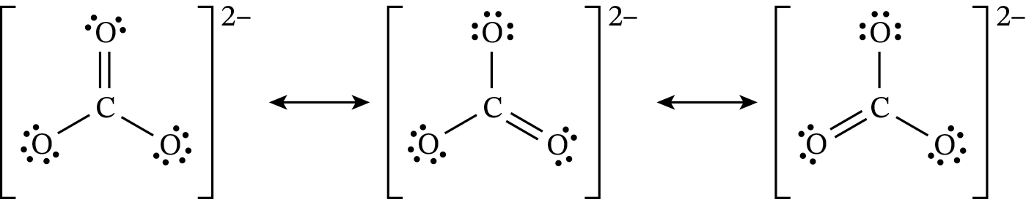
In all structures, the negative charges could also be shown on the single-bonded O atoms (one negative charge on each). Either way of representing the charges is acceptable.
All three resonance structure contribute equally to the structure of the actual ion, so all three carbon to oxygen bonds have equal bond orders $1 1/3$ nn and therefore equal lengths. The actual bond lengths in this ion are intermediate between those for C–O and C=O bonds.
- To score full marks, you need to draw any two of the following diagrams:
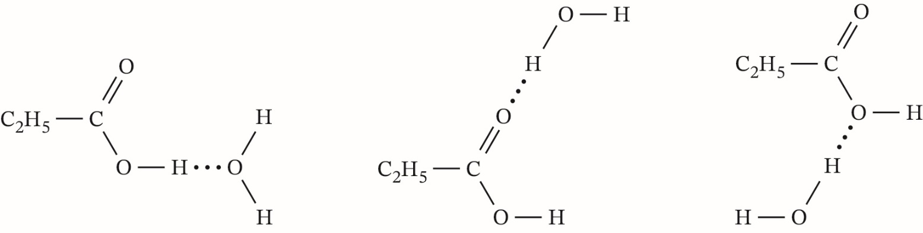
- In contrast to HCl, the molecules of HF can form hydrogen bonds with one another. Therefore, HF has a higher boiling point than HCl.

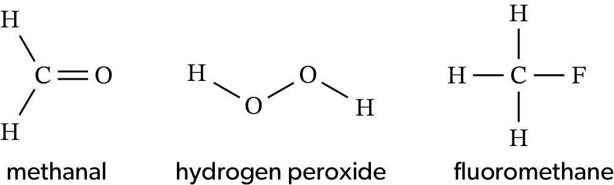
  - Only the molecules of hydrogen peroxide can form hydrogen bonds with one another, so this substance is likely to be liquid at 298 K
- Spot 1: $R_F=(1.3 cm)/(9.3 cm)≈0.14$
Spot 2: $R_F=(3.0 cm)/(9.3 cm)≈0.32$
Spot 3: $R_F=(3.6 cm)/(9.3 cm)≈0.39$
- A
- B
- In structure A, both C and S atoms have zero formal charges, so ΔFC = 0. In structure B, the formal charges of C and S atoms are −2 and +2, respectively, so ΔFC = 4. Therefore, structure A is preferred, as it has the lowest ΔFC value.

Species | Lewis (electron dot) formula | Electron domain geometry | Molecular geometry | Bond angle(s)
[IBr₄]⁻ | 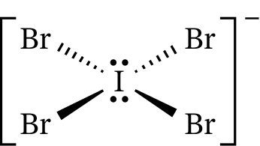 | octahedral | square planar  (AB₄E₂) | 90°
[IF₄]⁺ | 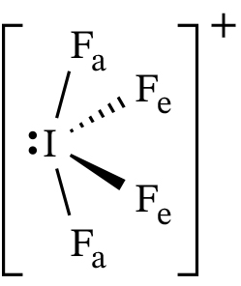 | trigonal bipyramidal | see-saw  (AB₄E) | less than 90° (F_{a}–I–F_{e}) and less than 120° (F_{e}–I–F_{e})
F_{a} = axial fluorine, F_{e} = equatorial fluorine. To save space, the lone electron pairs on Br and F atoms are omitted. In full Lewis structures, each of these atoms must have three lone electron pairs.
- C

2.3 The metallic model
- B
- Magnesium has more delocalized electrons per atom (two instead of one), higher ionic charge (2+ instead of 1+) and smaller ionic radius (72 pm instead of 102 pm) than sodium. All three factors increase the strength of metallic bonding and thus the melting point of magnesium as compared with sodium.

2.4 From models to materials
- PCl₃: $χ ̅$ = 2.7, Δχ = 1.0 so polar covalent.
HCl: $χ ̅$ = 2.7, Δχ = 1.0, so polar covalent.
MgF₂: $χ ̅$ = 2.7, Δχ ≈ 2.7, so ionic.
F₂: $χ ̅$ = 4.0, Δχ = 0, so non-polar covalent.
KBr: $χ ̅$ = 1.9, Δχ = 2.2, so ionic.
PbBr₂: $χ ̅$ = 2.4, Δχ = 1.2, so polar covalent.
- Ions of aluminium and those of other metals have different sizes, so the lattice of an aluminium alloy is less regular than the lattice of pure aluminium. The layers of cations in the alloy cannot slide past one another as easily as those in aluminium, so a sample of the alloy is less likely to be deformed without cracking.

  - C₆H₅–CH=CH₂.
  - The monomer (styrene) is not a homologue of benzene. Homologues are compounds that differ by one or more CH₂ groups and are otherwise similar structures. Styrene has an extra C=C bond when compared to benzene and so they are not homologues.

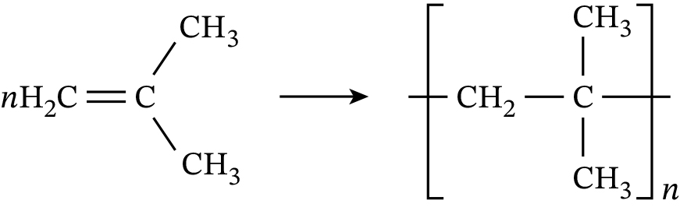

  - –NHCH₂CH₂NHC(O)CH₂C(O)NHCH₂CH₂NHC(O)CH₂C(O)–
  - H₂O
  - M(ethane-1,2-diamine) = 60.12 g mol⁻¹
M(propanedioic acid) = 104.07 g mol⁻¹
M(H₂O) = 18.02 g mol⁻¹
The reaction of 1 mol of ethane-1,2-diamine with 1 mol of propanedioic acid produces 2 mol of water, so every 60.12 g + 104.07 g = 164.19 g of the monomers give 2 × 18.02 g = 36.04 g of water and 164.19 g − 36.04 g = 128.15 g of the polymer. Therefore:
$$atom economy=(128.15 g)/(164.19 g)×100≈78.05\%$$

Structure 3—Classification of matter

3.1 The periodic table: classification of elements
- B
- B
- Ba and Zn are metals; Ge is a metalloid; I, P and H are non-metals.

  - Co³⁺: [Ar]3d⁶
Zn²⁺: [Ar]3d¹⁰
  - Zinc has a complete d-sublevel (3d¹⁰) in all its compounds. In contrast, cobalt forms ions with an incomplete d-sublevel.

  - Both elements have their valence electrons in the same energy sublevel (3s) and identical number of core electrons (10), so the shielding effects in both elements are similar. Magnesium has a higher nuclear charge (Z = 12) than sodium (Z = 11), so the valence electrons in magnesium experience a stronger electrostatic attraction to the nucleus than the valence electron in sodium. As a result, the atomic radius of magnesium is smaller than that of sodium, and the removal of an electron from a magnesium atom requires more energy than the removal of an electron from a sodium atom.
  - See answers to practice exam paper 2, question 1(a). Other acceptable equations may include reactions of Na₂O with acids or water and reactions of oxides of chlorine with bases or water.
  - The reactivity of halogens decreases down group 17, so bromine is less reactive than chlorine but more reactive than iodine. When bromine water is added to aqueous potassium iodide, elemental bromine will oxidize iodide ions to elemental iodine:
Br₂(aq) + 2KI(aq) → I₂(aq) + 2KBr(aq) (molecular equation)
Br₂(aq) + 2I⁻(q) → I₂(aq) + 2Br⁻(aq) (net ionic equation)
Depending on the reaction conditions, aqueous or solid iodine can be produced. The solution colour will change from yellow, orange or brown (aqueous bromine, depending on the concentration) to a darker brown (iodine water), and a dark-brown or dark-violet solid might appear (solid iodine). When bromine water is added to aqueous potassium chloride, no reaction will occur and therefore no visible changes will be observed.

Formula | Systematic name | Oxidation states
MnO₂ | manganese(IV) oxide | Mn +4, O −2
NH₄NO₂ | ammonium nitrate(III) | N −3 (in NH4⁺), H +1,
Na₂SO₄ | sodium sulfate(VI) | N +3 (in NO₂⁻), O −2
PCl₅ | phosphorus(V) chloride | Na +1, O −2, S +6
Mg(HCO₃)₂ | magnesium hydrogencarbonate | P +5, Cl −1
NH₄F | ammonium fluoride | Mg +2, H +1, C +4, O −2

  - The configurations of valence electrons in magnesium and aluminium are 3s² and 3s²3p¹, respectively. The 3p¹ electron in aluminium is shielded from the nucleus by the completely filled 3s-sublevel, so its removal requires less energy than the removal of a 3s electron from magnesium.
  - In sulfur, the two paired 3p electrons occupy the same orbital, which increases their mutual repulsion and thus lowers the energy required to remove one of these electrons. In contrast, all 3p electrons in phosphorus are unpaired, and the removal of any of these electrons will break the symmetry of the half-filled 3p-sublevel. Therefore, the ionization of phosphorus requires more energy than the ionization of sulfur.

  - Ethanediamine (H₂NCH₂CH₂NH₂), also known as ethylenediamine, is a neutral molecule, so the charge of this ligand is zero. Oxalate (C₂O₄²⁻), also known as ethanedioate, has a charge of 2− (see table 2 page 3 in Student Book, Subtopic 1.1).
  - Coordination bonding (a special case of covalent bonding).
  - Nickel(II) acts as a Lewis acid and the ligands act as Lewis bases.
  - The wavelength 580 nm corresponds to yellow light, so the complex will be violet because violet colour is complementary to yellow (figure 8).
  - λ = 580 nm = 5.8 × 10⁻⁷ m
$$f=c/λ=(3.0×10^(8 ) m s^(-1))/(5.8×10^(-7) m)≈5.2×10^(14 ) s^(-1)$$
Δ = h × f = 6.63 × 10⁻³⁴ J s × 5.2 × 10¹⁴ s⁻¹ ≈ 3.4 × 10⁻¹⁹ J

3.2 Functional groups: Classification of organic compounds
- B
- B

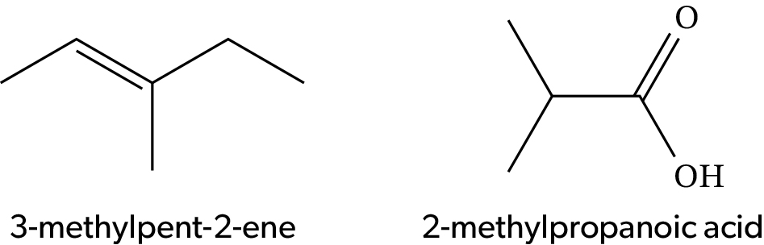
  - All covalent bonds in 3-methylpent-2-ene are almost non-polar, so its molecules experience only weak London dispersion forces between molecules. In contrast, the molecules of 2-methylpropanoic acid can form much stronger hydrogen bonds with one another, and they also experience dipole–dipole interactions (in addition to London dispersion forces). The stronger intermolecular forces in 2-methylpropanoic acid require more energy to break, so the boiling point of this compound is higher than that of 3-methylpent-2-ene.

  - The molecule of 2-amino-3-methylbutan-1-ol contains a chiral carbon atom (marked with an asterisk), so this compound can show optical activity.

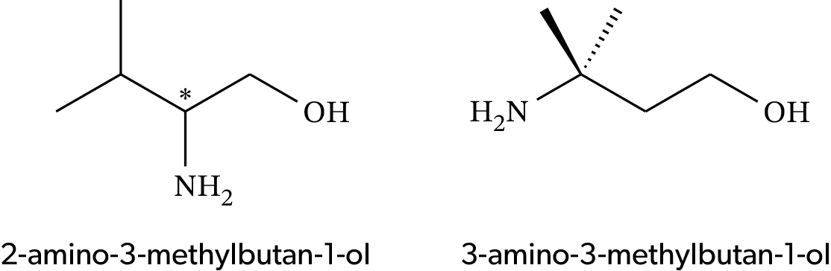
The molecule of 3-amino-3-methylbutan-1-ol has no chiral carbon atoms, so this compound is optically inactive.

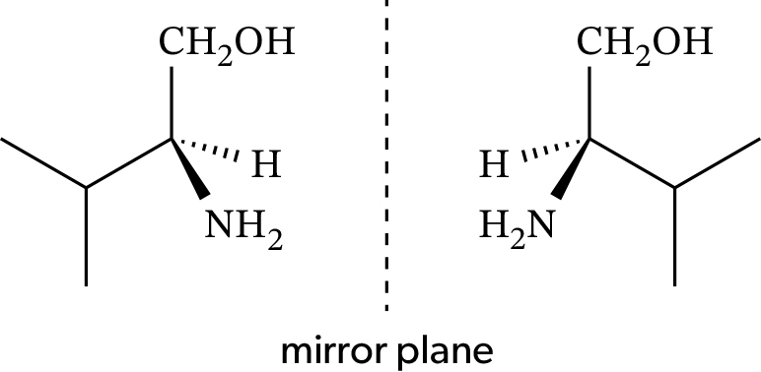

  - They can be distinguished by the use of a polarimeter. Solutions of the two enantiomers of 2-amino-3-methylbutan-1-ol will rotate the plane of plane-polarized light in opposite directions while the optically inactive 3-amino-3-methylbutan-1-ol will show no rotation.

  - 1720 cm⁻¹ is C=O; 3000 cm⁻¹ is C–H.
  - m/z 15 (CH₃⁺), m/z 43 (CH₃CO⁺), m/z 58 (molecular ion, C₃H₆O⁺).
  - One signal, because all hydrogen atoms in the molecule have the same chemical environment.
  - Singlet at 2.2–2.7 ppm.

  - Let m(sample) = 100 g, then:
m(C) = 54.52 g, n(C) = 4.54 mol
m(H) = 9.17 g, n(H) = 9.08 mol
m(O) = 100 − 54.52 − 9.17 = 36.31 g, n(O) = 2.27 mol
n(C) : n(H) : n(O) = 4.54 : 9.08 : 2.27 = 2 : 4 : 1
Therefore, the empirical formula is C₂H₄O.
Mr(C₂H₄O) = 44.06, so the molecular formula is identical to empirical, C₂H₄O.
  - The absorption at 1725 cm⁻¹ in the IR spectrum corresponds to a C=O bond, so compound X is an aldehyde, CH₃CHO (ethanal). The absorption band at 2975 cm⁻¹ corresponds to C–H bonds in CH₃ and CHO groups.
  - m/z 15 is CH₃⁺; m/z 29 is CHO⁺.
  - Two signals (one for the CH₃ group and another for the CHO group); integration ratio 3 : 1.
  - CH₃: doublet at 2.2–2.7 ppm; CHO: quartet at 9.4–10 ppm.

  - The IR spectrum shows the absorptions of C–H bonds at 2900–3000 cm⁻¹, a C=O bond at 1780 cm⁻¹ and possibly a C–O bond at 1200 cm⁻¹. There are no absorptions above 3000 cm⁻¹, so the compound does not contain any O–H bonds. Therefore, it is a carbonyl compound with two O atoms, most likely an ester.
The ¹H NMR spectrum shows three signals in 3 : 2 : 3 ratio, which suggests the presence of one CH₂ and two CH₃ groups. The signal of one CH₃ group (at 3.7 ppm) is a singlet, so this group has no adjacent atoms with H attached. The other two signals form a characteristic pattern of an ethyl group, CH₃CH₂ (a triplet of CH₃ at 1.2 ppm and a quartet of CH₂ at 2.3 ppm). Assuming that compound Z is an ester, there are only two possible structures:
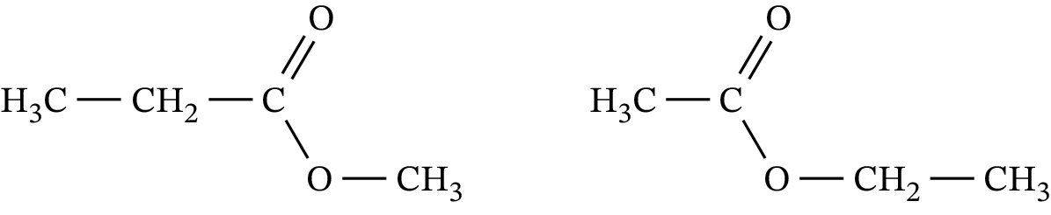
According to section 21 of the data booklet, the signal of the OCH₃ group in the LHS structure would appear at 3.7–4.8 ppm, which matches the spectrum (singlet at 3.7 ppm). The signal of the CH₃CO group in the RHS structure would appear at 2.0–2.5 ppm, but the spectrum shows no singlet in that region. Therefore, the LHS structure is the only possible answer.
The MS also agrees with the LHS structure because it shows a strong peak of CH₃CH₂CO⁺ (m/z 57), which would be absent (or very weak) in the RHS structure.

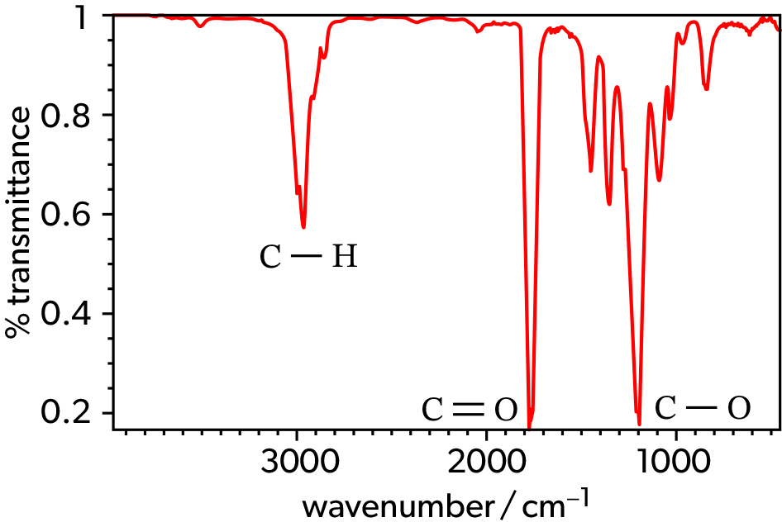
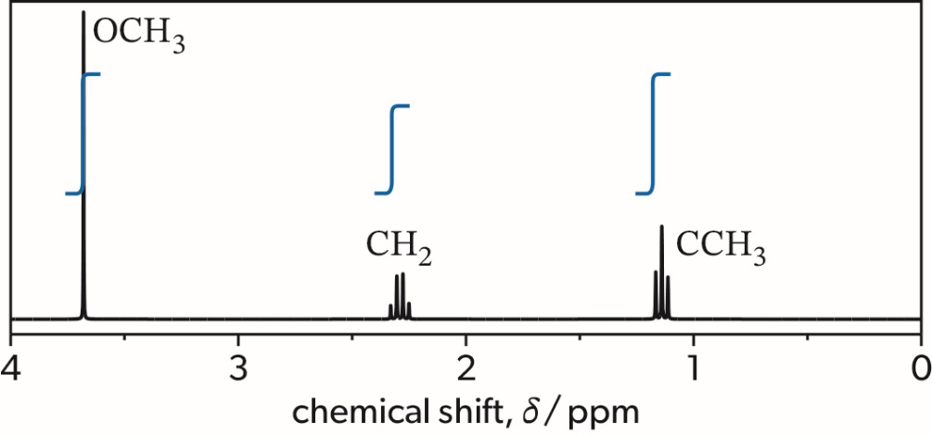
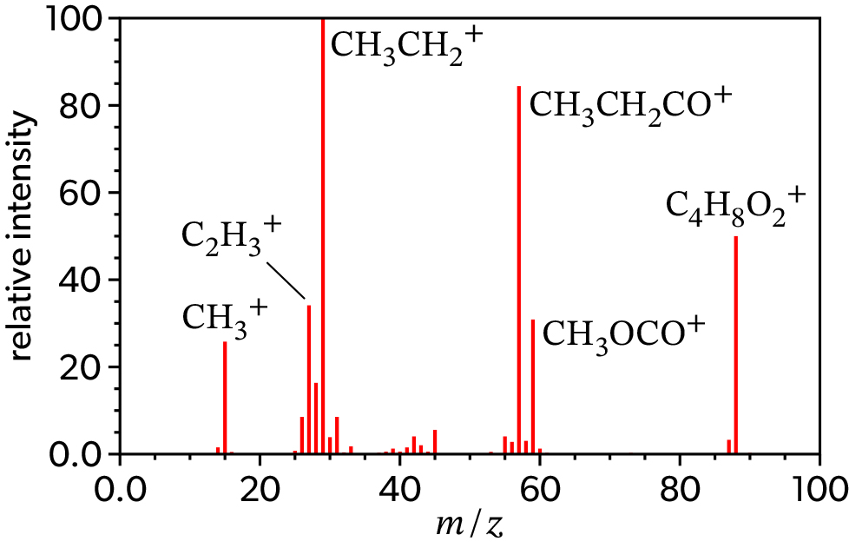

Reactivity 1—What drives chemical reactions?

1.1 Measuring enthalpy changes
- A
- C
- See figure 2 (right) in Student Book, Subtopic Reactivity 2.2.

  - Your answer can include any two of the following assumptions:
- no heat is lost to the surroundings
- the specific heat capacity of the solution is the same as that of pure water
- the specific heat capacities of zinc metal, calorimeter, thermometer, etc. are negligible
- the mass of the reaction mixture does not change during the reaction
- the density of the reaction mixture is 1.00 g cm⁻³
  - The temperature shown by the dashed red line at t = 100 s is 73 °C, and the initial temperature is 24.5 °C, so ΔT = 73 °C − 24.5 °C = 48.5 °C.
Notice that the extrapolated temperature can also be obtained from the linear fit equation:
T = −0.050 × 100 + 78.0 = 73 °C
  - If the density of the reaction mixture is 1.00 g cm⁻³, then:
m = 50.0 cm³ × 1.00 g cm⁻³ = 50.0 g
Q = 50.0 g × 4.18 J g⁻¹ K⁻¹ × 48.5 K ≈ 10 100 J = 10.1 kJ
Notice that ΔT has the same numerical values in °C and K.
  - Zinc metal was in excess, so Cu²⁺(aq) was the limiting reactant. Therefore:
V = 50.0 cm³ = 0.0500 dm³
n(Cu²⁺) = 0.0500 dm³ × 1.00 mol dm⁻³ = 0.0500 mol
$$ΔH=(10.1 kJ)/(0.0500 mol)=202 kJ 〖mol〗^(-1)$$
If the intermediate results were not rounded, the final answer would be 203 kJ mol⁻¹, which is also acceptable.

1.2 Energy cycles in reactions
- D
- A
- Bond length: ca. 135 pm (average between 148 and 121 pm for O–O and O=O bonds, respectively). Notice that the actual bond lengths in ozone are 128 pm, which is close to the predicted value.
BE value: 321 kJ mol⁻¹ (average between 144 and 498 kJ mol⁻¹ for O–O and O=O bonds, respectively).

  - Evaporation of water: H₂O(l) → H₂O(g)
$$ΔH_evap^⊝ (H_2 O)=-242 kJ 〖mol〗^(-1)-(-286 kJ 〖mol〗^(-1) )=44 kJ 〖mol〗^(-1)$$
Notice that H₂O(g) in section 13 of the data booklet is listed as “steam”.
  - All BE values are calculated for gaseous species while the combustion of ethane under standard conditions produces liquid water. Therefore, the value of $ΔH_c^(⊝) (C_2 H_6 )$ obtained in part (a) of example 3 should be reduced by 44 kJ mol⁻¹ for each mole of water formed in the reaction. The combustion of ethane produces three moles of water, so:
$$ΔH_c^⊝ 〖(C〗_2 H_6 )_corrected= ΔH_c^⊝ (C_2 H_6 )-3×ΔH_evap^⊝ (H_2 O)$$
= −1421 kJ mol⁻¹ − 3 × (44 kJ mol⁻¹)
= −1553 kJ mol⁻¹
Notice that the corrected value is very close to the actual enthalpy of combustion of ethane given in section 14 of the data booklet (−1561 kJ mol⁻¹).

  - CH₃OH(l) + 1.5O₂(g) → CO₂(g) + 2H₂O(l) $ΔH_c^⊝ (CH_3 OH)=-726 kJ 〖mol〗^(-1)$
H₂(g) + 0.5O₂(g) → H₂O(l) $ΔH_f^⊝ (H_2 O)=-286 kJ 〖mol〗^(-1)$
  - First, write down the equations representing standard enthalpies of formation for the reactant (methanol) and products (carbon dioxide and water):
    - C(s, graphite) + 2H₂(g) + 0.5O₂(g) → CH₃OH(l) $ΔH_f^⊝ (〖CH〗_3 OH)=-239 kJ 〖mol〗^(-1)$
    - C(s, graphite) + O₂(g) → CO₂(g) $ΔH_f^⊝ (〖CO〗_2 )=-394 kJ 〖mol〗^(-1)$
    - H₂(g) + 0.5O₂(g) → H₂O(l) $ΔH_f^⊝ (H_2 O)=-286 kJ 〖mol〗^(-1)$
According to part (a), the combustion of 1 mol of methanol under standard conditions produces 1 mol of CO₂(g) and 2 mol of H₂O(l). Therefore, to obtain the standard enthalpy of combustion of methanol, we need to combine equations (i)–(iii) as follows:
(ii) + 2 × (iii) − (i)
C(s, graphite) + O₂(g) + 2H₂(g) + O₂(g) − C(s, graphite) − 2H₂(g) − 0.5O₂(g)
→ CO₂(g) + 2H₂O(l) − CH₃OH(l)
Cancelling out C(s, graphite) and 2H₂(g) and rearranging the remaining terms gives an equation that represents the standard enthalpy of combustion of methanol:
CH₃OH(l) + 1.5O₂(g) → CO₂(g) + 2H₂O(l)
Therefore, the expression $ΔH_r^⊝=∑▒〖(ΔH_f^⊝ products)-〗 ∑▒〖ΔH_f^⊝ reactants〗$ is valid.
This conclusion can also be confirmed by combining the enthalpy of formation values for the reactants and products. Remember that $ΔH_f^⊝$ for any elementary substance, such as O₂(g), is zero by definition:
−394 kJ mol⁻¹ + 2 × (−286 kJ mol⁻¹) − (−239 kJ mol⁻¹) = −727 kJ mol⁻¹
The difference between the final value and the actual enthalpy of combustion of methanol (−726 kJ mol⁻¹) is caused by rounding errors: all values given in sections 13 and 14 of the data booklet are rounded to the nearest whole numbers.

  - Al(s) → Al(g) $ΔH_at^⊝ (Al)= ΔH_sub^⊝ (Al)$
  - 0.5N₂(g) → N(g) $ΔH_at^⊝ (N)= 0.5 BE(N≡N)$
  - 0.5Br₂(l) → Br(g) $ΔH_at^⊝ (Br)= 0.5ΔH_evap^⊝ (Br_2)+0.5BE(Br-Br)$
(“sub” = sublimation; “evap” = evaporation)

  - Ca(s) + 0.5O₂(g) → CaO(s)

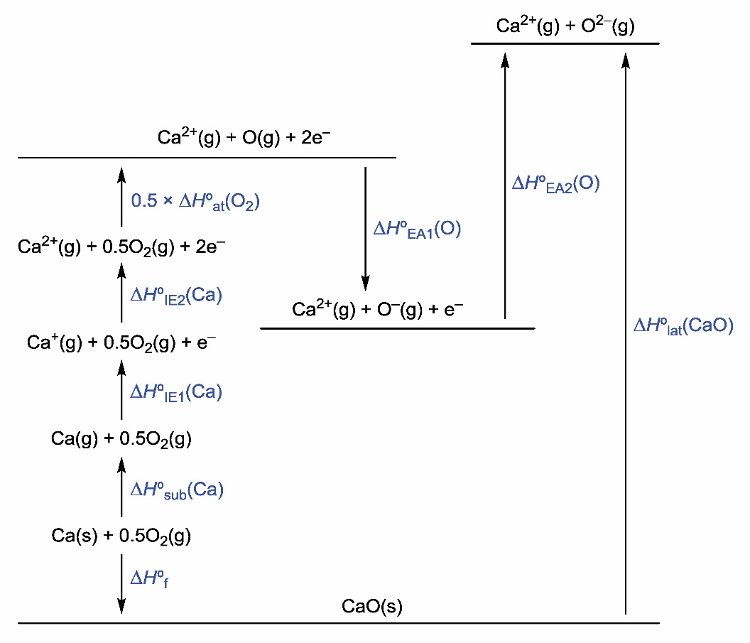
  - It is convenient to replace the enthalpies in the Born–Haber cycle from part (b) with their numerical values in kJ mol⁻¹:
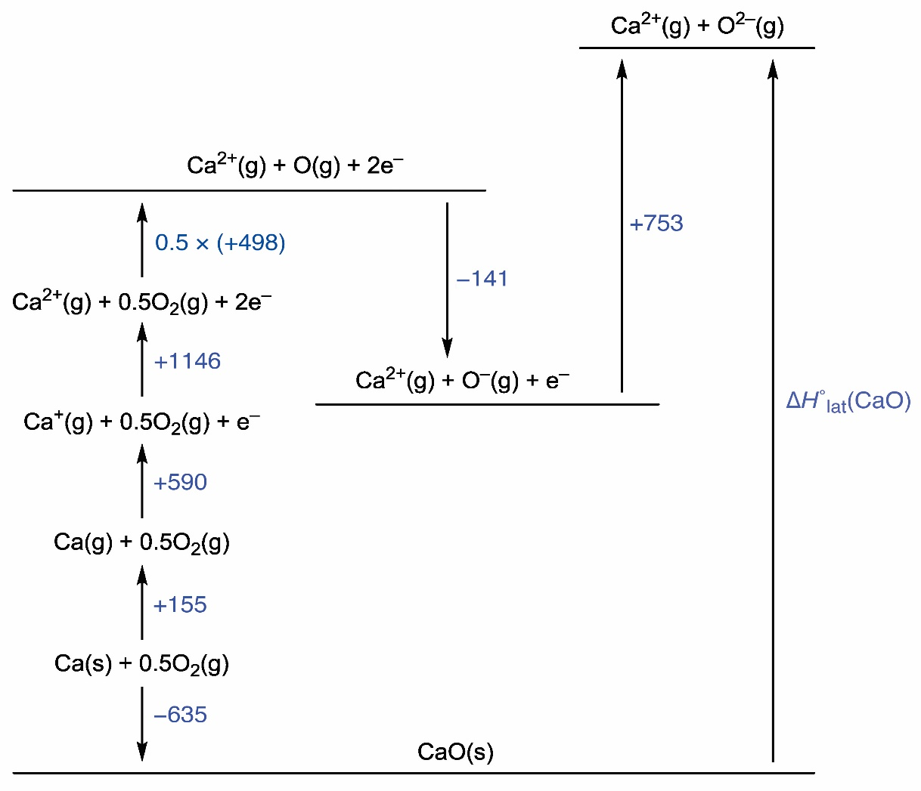
Notice that $ΔH_at^⊝ (O_2 )$ is equal to BE(O=O), which is given in section 12 of the data booklet. The values of $ΔH_IE1^⊝ (Ca),ΔH_IE1^⊝ (O)$ and $ΔH_IE2^⊝ (O)$are given in section 9 of the data booklet.
According to the diagram,
$ΔH_lat^⊝ (CaO)$ = −(−635) + 155 + 590 + 1146 + 0.5 × 498 + (−141) + 753
= +3387 kJ mol⁻¹
This answer is very close to the actual lattice enthalpy of calcium oxide (+3401 kJ mol⁻¹), which is given in section 16 of the data booklet.

1.3 Energy from fuels
- m(C₇H₈) = 2.00 × 10³ kg = 2.00 × 10⁶ g
M(C₇H₈) = 92.15 g mol⁻¹
n(C₇H₈) = $(2.00×10^6 g)/(92.15 g 〖mol〗^(-1) )=2.17×10^(4 ) mol$
C₇H₈ + 9O₂ → 7CO₂ + 4H₂O
n(CO₂) = 7 × n(C₇H₈) = 7 × 2.17 × 10⁴ mol ≈ 1.52 × 10⁵ mol
M(CO₂) = 44.01 g mol−1
m(CO₂) = 1.52 × 10⁵ mol × 44.01 g mol⁻¹ ≈ 6.69 × 10⁶ g = 6.69 tonnes

  - Complete combustion:
C₈H₁₈(l) + 12.5O₂(g) → 8CO₂(g) + 9H₂O(l)
Incomplete combustion:
C₈H₁₈(l) + 8.5O₂(g) → 8CO(g) + 9H₂O(l)
  - Subtracting the second equation in part (a) from the first equation in the same part gives the following equation:
8CO(g) + 4O₂(g) → 8CO₂(g)
This means that the difference in thermal effects of the complete and incomplete combustion of octane is equal to the enthalpy of combustion of eight moles of carbon monoxide.
According to section 14 of the data booklet, $ΔH_c^⊝ (CO,g)$ = −283 kJ mol⁻¹. Since this value is negative, the second reaction produces less heat than the first reaction.
The same result could be obtained by applying the equation
$ΔH_r^⊝=∑▒〖(ΔH_c^⊝ reactants)-〗 ∑▒〖ΔH_c^⊝ products〗$ to each of the two reactions in part (a):
$$ΔH_r1^⊝=ΔH_c^⊝ (C_8 H_18, I)=-5470 kJ 〖mol〗^(-1)$$
(Notice that oxygen, carbon dioxide and water cannot be combusted, so their $ΔH_c^⊝$ values are equal to zero.)
$$ΔH_r2^⊝=ΔH_c^⊝ (C_8 H_18, I)-8×ΔH_c^⊝ (CO,g)$$
$$=-5470 kJ 〖mol〗^(-1)-8×(-283 kJ 〖mol〗^(-1) )$$
$$=-3206 kJ 〖mol〗^(-1)$$
$$ΔH_r1^⊝>ΔH_r2^⊝,so Q_1>Q_2$$
  - Incomplete combustion is less exothermic than complete combustion, so the car will consume more fuel per mile. Any carbon monoxide produced by the incomplete combustion of the fuel will eventually be oxidized in the atmosphere to carbon dioxide:
CO(g) + 0.5O₂(g) → CO₂(g)
Therefore, the total amount of carbon dioxide produced by the car (directly or indirectly) will increase, and so will the carbon footprint.
- The type of the best-fit equation (y = mx + b) and the high value of R² = 0.86 mean that the correlation observed is approximately linear (within the given range of CO2 levels). The positive value of the coefficient m = 0.012 means that the correlation is positive: when the carbon dioxide level increases, the temperature also increases. The high value of R² means that the correlation is strong, so any changes in the dependent variable (temperature anomaly) are likely to be caused by the change in the independent variable (CO₂ level). Since CO₂ is a greenhouse gas, the temperature anomaly can be related to the greenhouse effect of that gas.
Notice that the y-intercept value, b = −3.84 °C, has no physical meaning because the zero point for the temperature anomaly is set arbitrarily at c(CO₂) = 320 ppm

  - 6CO₂(g) + 6H₂O(l) → C₆H₁₂O₆(aq) + 6O₂(g)
  - Carbon is reduced because its oxidation state changes from +4 in CO₂(g) to 0 in C₆H₁₂O₆(aq). Oxygen is oxidized because its oxidation state changes from −2 in CO₂(g) to 0 in O₂(g).
  - The carbon emissions of biofuels are largely offset by the biological carbon fixation in the green plants used for the production of these fuels.

  - Anode: CH₃OH(aq) + H₂O(l) → CO₂(g) + 6H⁺(aq) + 6e⁻
Cathode: O₂(g) + 4H⁺(aq) + 4e⁻ → 2H₂O(l)
  - Advantages:
- DMFCs can be used continuously (they do not need to be recharged) while lead–acid batteries must be recharged periodically
- DMFCs have higher specific energy and higher energy density than lead–acid batteries
- in contrast to lead–acid batteries, DMFCs do not contain toxic lead compounds.
Disadvantages:
- DMFCs are more expensive than lead–acid batteries
- DMFCs typically produce lower electric current than lead–acid batteries
- in contrast to lead–acid batteries, DMFCs need a constant supply of fuel
- in contrast to lead–acid batteries, DMFCs use a toxic and flammable fuel (methanol)
- in contrast to lead–acid batteries, DMFCs work well only when hot
- in contrast to lead–acid batteries, DMFCs produce a greenhouse gas (carbon dioxide)
- in contrast to lead–acid batteries, the electrodes in DMFCs can be poisoned by impurities in the fuel.
To score full marks, you need to mention any one advantage and any one disadvantage.

1.4 Entropy and spontaneity
- B
- D
- If a liquid does not freeze or boil spontaneously under certain conditions (T₀ and p₀), then the ΔG values for both freezing and boiling of that liquid at T₀ are positive. Boiling is endothermic (ΔH_{b} > 0), and the entropy change of boiling is positive (ΔS_{b} > 0). According to the Gibbs equation, if ΔG_{b} > 0, then ΔH_{b} > T₀ ΔS_{b}. The boiling will become spontaneous only when T₀ΔS_{b} increases, which can only happen when the temperature increases (T_{b} > T₀). Freezing is exothermic (ΔH_{f} < 0), and the entropy change of freezing is negative (ΔS_{f} < 0). According to the Gibbs equation, if ΔG_{f} > 0, then ΔH_{f} > T₀ΔS_{f}. The freezing will become spontaneous only when T₀ΔS_{f} increases (becomes less negative), which can only happen when the temperature decreases (T_{f} < T₀).
Therefore, if T_{b} > T₀ and T_{f} < T₀, then T_{b} > T_{f}.

  - $ΔH^⊝$ = −1159 − [−635 + (−297)] = −227 kJ mol⁻¹
  - $ΔS^⊝$ = 101 − (38 + 248) = −185 J K⁻¹ mol⁻¹
  - $ΔG^⊝$= −227 kJ mol−1 − 298 K × (−0.185 kJ K⁻¹ mol⁻¹) ≈ −172 kJ mol⁻¹
Notice that temperature was converted to kelvin, and $ΔS^⊝$to kJ K⁻¹ mol⁻¹ (to match the units of $ΔH^⊝$).
  - For a non-spontaneous reaction, $ΔG^⊝>0$. According to the Gibbs equation, $ΔG^⊝>0$ when $ΔH^⊝>T_0$ $ΔS^⊝$. Therefore:
−227 kJ mol⁻¹ > T × (−0.185 kJ K⁻¹ mol⁻¹)
T × 0.185 kJ K⁻¹ mol⁻¹ > 227 kJ mol⁻¹
T > 1227 K, or T > 954 °C

  - $In K=-(13,800 J〖 mol〗^(-1))/(8.31 J K^(-1) 〖mol〗^(-1)×473 K)≈-3.51$
K ≈ 0.030
Notice that temperature was converted to kelvin, and $ΔG^⊝$ to J mol⁻¹ (to match the units of R).
  - Q = $0.10/(0.75×0.50)$ ≈ 0.267
ΔG = 13 800 J mol⁻¹ + 8.31 J K⁻¹ mol⁻¹ × 473 K × ln(0.267) ≈ 8610 J mol⁻¹ = 8.61 kJ mol⁻¹
  - ΔG > 0, so the reverse reaction is spontaneous.

Reactivity 2—How much, how fast and how far?

2.1 How much? The amount of chemical change
- A
- D

  - C₃H₈(g) + 5O₂(g) → 3CO₂(g) + 4H₂O(l)
  - n(C₃H₈) =$(4.00 g)/(44.11 g 〖mol〗^(-1) )≈0.0907 mol$
n(O₂) = $(68.2 g)/(32.00 g 〖mol〗^(-1) )≈2.13 mol$
According to the equation, the complete combustion of 0.0907 mol of propane requires 5 × 0.0907 ≈ 0.454 mol of oxygen. The amount of oxygen in the reaction mixture (2.13 mol) is greater than required, so propane is the limiting reactant.
  - n(CO₂) = 3 × n(C₃H₈) = 3 × 0.0907 mol = 0.272 mol
m(CO₂) = 0.272 mol × 44.01 g mol⁻¹ ≈ 12.0 g

  - NaOH(aq) + HCl(aq) → NaCl(aq) + H₂O(aq)
  - n(NaOH) = 0.0200 dm³ × 0.200 mol dm⁻³ = 0.00400 mol
n(HCl) = 0.0300 dm³ × 0.100 mol dm⁻³ = 0.00300 mol
HCl is the limiting reactant, so n(NaCl) = n(HCl) = 0.00300 mol. The final solution also contains 0.00400 − 0.00300 = 0.00100 mol of unreacted NaOH.
V_{final} = V₁ + V₂ = 50.0 cm³ = 0.0500 dm³
c(NaCl)_{final} = $(0.00300 mol)/(0.0500 dm^3 )$ = 0.0600 mol dm⁻³
c(NaOH)_{final} = $(0.00100 mol)/(0.0500 dm^3 )$ = 0.0200 mol dm⁻³
Notice that both NaCl and HCl are strong electrolytes (see Reactivity 3.1), so the actual species in the final solution are Na⁺(aq), Cl⁻(aq) and OH⁻(aq). The concentrations of these ions can be calculated from the concentrations of NaCl(aq) and NaOH(aq) as follows:
c(Na⁺)final = c(NaCl)final + c(NaOH)_{final} = 0.0800 mol dm⁻³
c(Cl⁻)_{final} = c(NaCl)final = 0.0600 mol dm⁻³
c(OH⁻)_{final} = c(NaOH)final = 0.0200 mol dm⁻³
In examination papers, either set of answers would be accepted.

- 2Ga(s) + 6HCl(aq) → 2GaCl₃(aq) + 3H₂(g)
The question states that hydrochloric acid is in excess, so gallium is the limiting reactant.
$$n(Ga)=(6.55 g)/(69.72 g 〖mol〗^(-1) )≈0.0939 mol$$
According to the equation, n(H₂) = 1.5 × n(Ga), so:
n(H₂) = 1.5 × 0.0939 mol ≈ 0.141 mol
Now we can use the ideal gas equation, pV = nRT, to calculate the volume of hydrogen:
T = 32 + 273 = 305 K, p = 90.5 kPa = 9.05 × 10⁴ Pa
$$V=(0.141 mol×8.31 J K^(-1) 〖mol〗^(-1)×305 K)/(9.05×10^4 Pa)≈3.95×10^(-3) m^3=3.95×10^3 〖cm〗^3$$
- In all cases, we need to divide the relative molecular mass of the target product by the sum of relative molecular masses of reactants.
  - atom economy = $73.11/(78.50+31.07)×100\%≈66.72\%$
  - atom economy =$46.08/(2×32.05)×100\%≈71.89\%$
  - atom economy = 100% (because all atoms from the reactants end up in the product)

2.2 How fast? The rate of chemical change
- D

  - At first, hydrogen gas is released at a certain rate, so the mass of the beaker with its contents decreases. As the acid is consumed, its concentration decreases, so the frequency of collisions between H⁺(aq) ions and Mg(s) also decreases. As a result, the curve becomes less steep. When the acid is consumed completely (magnesium is in excess), the release of gas stops, and the curve flattens out.

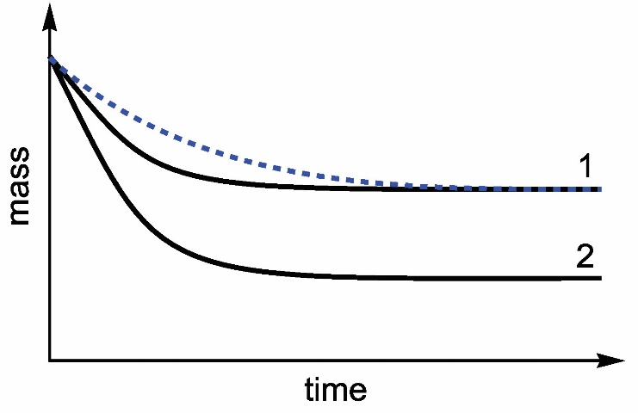
Notice that the curve is less steep than curve 1 but flattens out on the same level. The final mass loss depends on the quantity of the limiting reactant, HCl(aq), which is not affected by temperature.

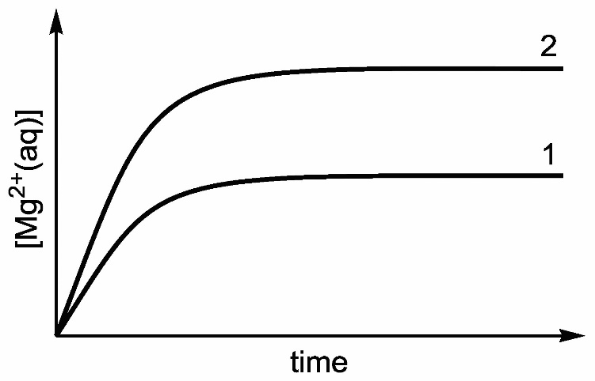
Notice that both curves must begin at the origin, as the initial solution does not contain Mg²⁺(aq).

  - Iodine is coloured while all other reactants and products are colourless. Therefore, the concentration of iodine can be monitored using a colorimeter. Alternatively, the solution pH can be monitored using a pH meter, as H⁺(aq) ions are consumed during the reaction.

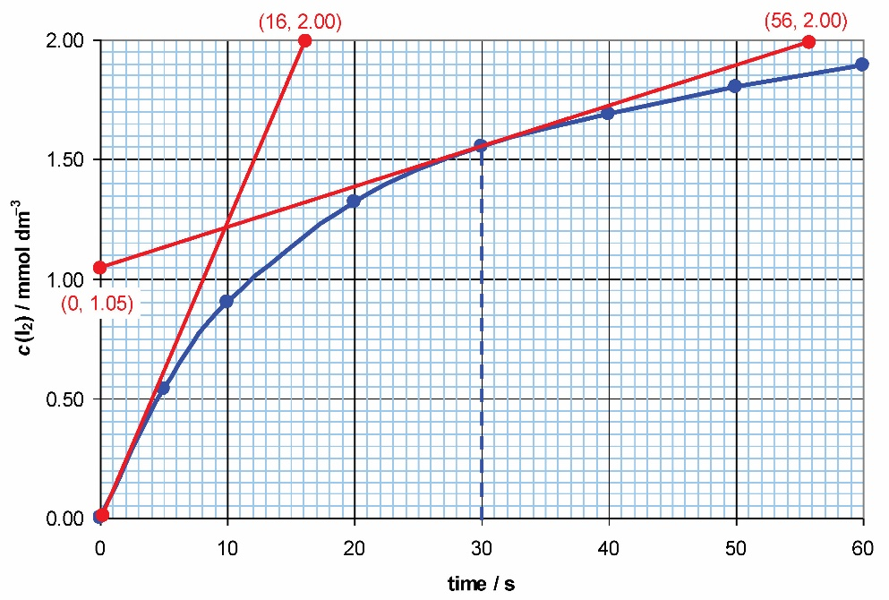
    - v_{avr30}(I₂) = $(∆c(I_2))/∆t=(1.55-0)/(30-0)≈$0.052 mmol dm⁻³ s⁻¹ = 5.2 × 10⁻⁵ mol dm⁻³ s⁻¹
Notice that c(I₂) in the table is given in mmol dm⁻³, so a conversion factor (1 mmol = 10⁻³ mol) must be applied.
    - To find the initial rate, we need to draw a tangent line to the curve at t = 0 and take any two points on this line (ideally, as far apart as possible), for example, (0, 0) and (16, 2.00):
v_{init}(I₂) = $(2.00-0)/(16-0)=$0.125 mmol dm⁻³ s⁻¹ ≈ 1.3 × 10⁻⁴ mol dm⁻³ s⁻¹
For the instantaneous rate at t = 30 s we need to draw a tangent line to the curve at that time and take any two points, for example, (0, 1.05) and (56, 2.00):
v_{inst30}(I₂) = $(2.00-1.05)/(56-0)≈$0.017 mmol dm⁻³ s⁻¹ ≈ 1.7 × 10⁻⁵ mol dm⁻³ s⁻¹
    - The stoichiometric coefficient before I₂(aq) in the equation is 3, so the overall initial rate will be three times lower than the initial rate with respect to I₂(aq):
v_{init} = $1/3$ v_{init}(I₂) = $0.125/3$ mmol dm⁻³ s⁻¹ ≈ 4.2 × 10⁻⁵ mol dm⁻³ s⁻¹
- B

  - a) ν = k[NO₂]². The answer “ν = k[NO₂]²[CO]⁰” would also be accepted, although it is a good practice to omit redundant factors.
  - The most common units for the reaction rate and concentration are mol dm⁻³ s⁻¹ and mol dm⁻³, respectively, so:
mol dm⁻³ s⁻¹ = (k)(mol dm⁻³)2 = (k) mol² dm⁻⁶
Therefore, the units for k are dm³ mol⁻¹ s⁻¹
  - If the second step were the RDS, then the reaction rate would depend on [CO], which is not the case. Therefore, step 1 is the RDS.
  - This is a second-order reaction, so the sketch will look as follows:

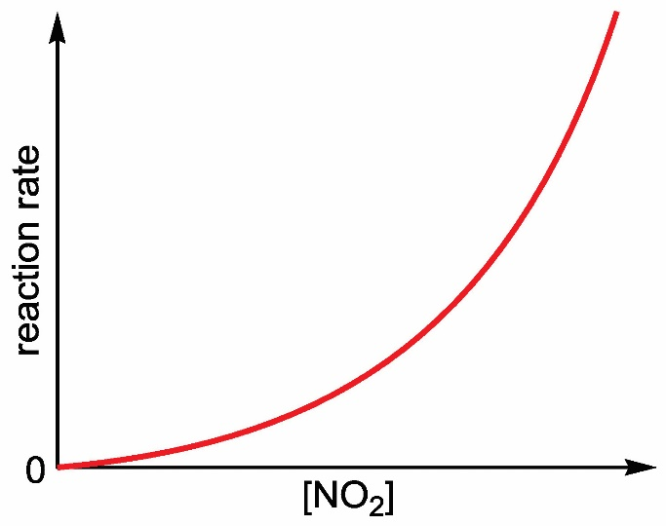
To score full marks, both axes must be labelled, and the curve must begin at the origin.
  - A catalyst will alter the reaction mechanism and introduce a new RDS with a lower activation energy, E_{a}.

2.3 How far? The extent of chemical change

  - $K=([N_2 ][H_2 ]^3)/([NH_3 ]^2 )$
  - $ΔH^⊝$ > 0 (see table 3 in the main text).
  - The new time–concentration curves are shown as dashed lines below.
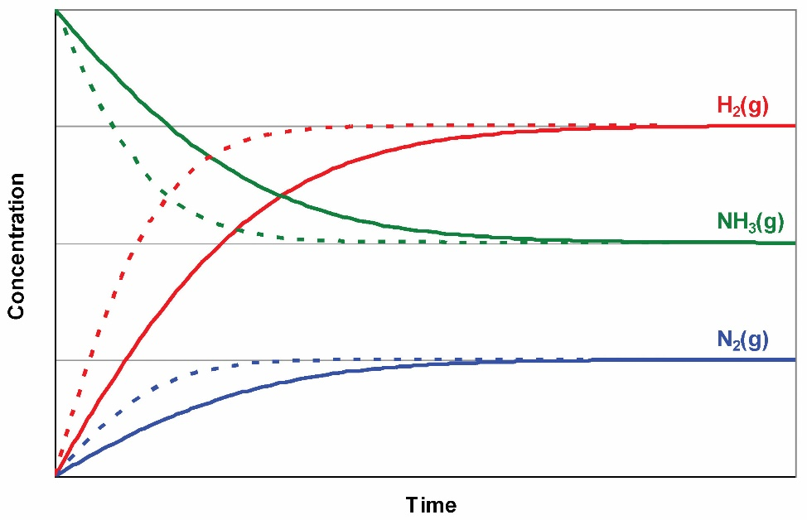
Notice that the catalyst increases the rates of both the forward and the reverse reactions by the same factor but does not affect the equilibrium position. As a result, all curves become steeper but flatten out at their original levels.
- B
- C

  - $ΔG^⊝$= −RT ln K, so:
lnK = $(25 200 J 〖mol〗^(-1))/(8.31 J K^(-1) 〖mol〗^(-1)×923 K)≈3.285$
K = e^{3.285} ≈ 26.7
Notice that the temperature is expressed in kelvin (650 + 273 = 923 K), and the Gibbs energy in joules per mole (−25.2 kJ mol⁻¹ = −25 200 J mol⁻¹).
  - When Q = K, the system is at equilibrium, so neither the forward nor the reverse reaction is favoured. Therefore, ΔG = 0. Notice that we are talking about ΔG, not $ΔG^⊝$, as at equilibrium the concentrations of reacting species may differ from their standard concentrations (1 mol dm⁻³).
In the general case, the $ΔG^⊝$ value for a reaction is nonzero even when the equilibrium is reached.

Reactivity 3—What are the mechanisms of chemical change?

3.1 Proton transfer reactions
- B
- C
- C
- Conjugate acid–base pairs:
H₂CO₃ (acid) and HCO₃⁻ (base)
HCO₃⁻ (acid) and CO₃²⁻ (base)
H₃O⁺ (acid) and H₂O (base)
H₂O (acid) and OH⁻ (base)
Amphiprotic species:
H₂O(l) and HCO₃⁻(aq)
Notice that OH⁻ and H₂CO₃ are also amphiprotic, as each species can lose and gain a proton. However, their conjugates O₂⁻ and H₃CO₃⁺, respectively, do not exist in aqueous solutions, so these answers are not acceptable.
- Ba(OH)₂(aq) → Ba²⁺⁽aq) + 2OH⁻(aq)
Notice that barium hydroxide is a strong base, so its dissociation is irreversible, and a straight arrow should be used.
[OH⁻] = 2 × c(Ba(OH)₂) = 2 × 2.00 × 10⁻³ = 4.00 × 10⁻³ mol dm⁻³
$[H^+ ] K_w/[OH^- ] =(1.00×10^(-14))/(4.00×10^(-3) )=2.5×10^(-12)$ mol dm⁻³
pH = −log[H⁺] = −log(2.5 × 10⁻¹²) ≈ 11.60
- H₂SO₄(aq) + Zn(s) → ZnSO₄(aq) + H₂(g) (molecular equation)
2H⁺(aq) + Zn(s) → Zn2⁺(aq) + H₂(g) (net ionic equation)
An ionic equation involving hydronium ions, H₃O⁺(aq), would also be acceptable:
2H₃O⁺(aq) + Zn(s) → Zn2⁺(aq) + H₂(g) + 2H₂O(l)

  - NH₃(aq) + H₂O(l) ⇌ NH₄⁺(aq) + OH⁻(aq)
K_{b}(NH₃) = 10^{−4.75} ≈ 1.78 × 10⁻⁵
[OH⁻] = $√(K_b×c(NH_3 ))=√(1.78×10^(-5)×0.10 )≈1.33×10^(-3) mol 〖dm〗^(-3)$
pOH = −log(1.33 × 10⁻³) ≈ 2.88
pH = 14 − pOH = 14 − 2.88 = 11.12
Alternative solution:
pOH = 0.5(pK_{b} − log c) = 0.5(4.75 − log(0.10)) ≈ 2.88
pH = 14 − 2.88 = 11.12
  - A fully annotated sketch is shown below.
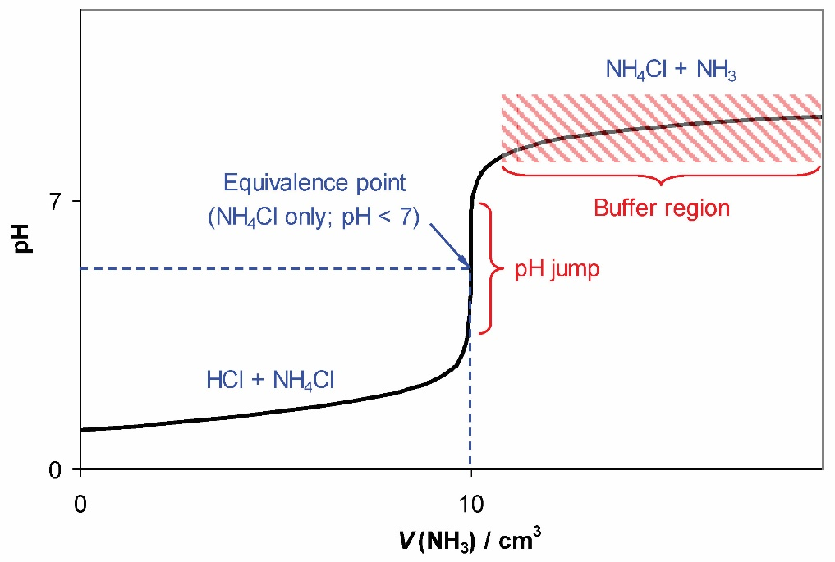
To score full marks, your sketch must show the labelled axes, the equivalence point at pH < 7 and the buffer region. All other labels are optional.
  - Any acid–base indicator with a pKa < 7 can be used, so the acceptable answers are methyl orange, bromophenol blue, bromocresol green and methyl red.
  - The overall shape will change very little, except that the left-hand side of the curve will be one pH unit higher, the equivalence point will be a fraction of a pH unit higher, and the pH jump will become less pronounced.
  - The curve from part (b) should be extended to V(NH₃) = 20 cm³. The pH at that point will be equal to pK_{a}(NH₄⁺). Ammonium (NH₄⁺) is a conjugate acid for ammonia (NH₃), so pK_{b}(NH₃) = 14 − pK_{a}(NH₄⁺).
In a typical IB examination paper, part (e) would be a three-mark question. The first mark would be awarded for mentioning half-equivalence point, the second for showing how to find pKa and the third for the relationship between pK_{a} and pK_{b}. Thus, the one-line answer “at half-equivalence pH = pK_{a} and pK_{b} = 14 − pK_{a}” will score all three marks.
  - Any one of the following two techniques can be used: conductometric titration (electrical conductivity measurement) and thermometric titration (temperature measurement). Notice that the answers like “conductivity probe” or “digital thermometer” will not score the mark, as these are the names of laboratory equipment, not techniques. At the same time, the answers “titration with a conductivity probe” and “titration with a digital thermometer” will be accepted, as they mention the technique (titration).

  - F⁻(aq) + H₂O(l) ⇌ HF(aq) + OH⁻(aq)
[H+] < [OH⁻], so pH > 7 (basic solution)
  - H₂O(l) ⇌ H+(aq) + OH−(aq)
[H⁺] = [OH⁻], so pH = 7 (neutral solution)
  - HCOO⁻(aq) + NH₄⁺(aq) ⇌ HCOOH(aq) + NH₃(aq)
(two separate equations for the hydrolysis of HCOO⁻ and NH₄⁺ ions are also acceptable)
H₂O(l) ⇌ H⁺(aq) + OH⁻(aq)
[H⁺] ≈ [OH⁻], so pH ≈ 7 (neutral or almost neutral solution)
  - CH₃NH₃⁺(aq) ⇌ CH₃NH₂(aq) + H⁺(aq)
or
CH₃NH3⁺(aq) + H₂O(l) ⇌ CH₃NH₂(aq) + H₃O⁺(aq)
[H⁺] > [OH⁻], so pH < 7 (acidic solution)
- Reaction with a strong acid:
HCOO⁻(aq) + H⁺(aq) → HCOOH(aq)
Reaction with a strong base:
HCOOH(aq) + OH⁻(aq) → HCOO⁻(aq) + H₂O(l)
Notice that the strong acid (H⁺) is neutralized by the conjugate base of the buffer (HCOO⁻) while the strong base (OH⁻) is neutralized by the conjugate acid of the buffer (HCOOH).
- M(Na₂CO₃) = 105.99 g mol⁻¹
n(Na₂CO₃) = $(0.400 g)/(105.99 g 〖mol〗^(-1) )≈0.00377 mol$
c(Na₂CO₃) =$(0.00377 mol)/(0.500 〖dm〗^3 )=0.0754 mol 〖dm〗^(-3)$
The dissociation of Na₂CO₃ produces CO₃²⁻(aq) ions, which act as the conjugate base of the buffer system. The dissociation of NaHCO₃ produces HCO₃⁻(aq) ions, which act as the conjugate acid. According to table 5, pK_{a}(HCO₃⁻) = 10.32. Therefore:
pH = 10.32 + log $(0.0754 mol〖 dm〗^(-3) )/(0.200 mol〖 dm〗^(-3) )≈9.90$
Alternative solution
Instead of using the Henderson–Hasselbalch equation, we can consider the equilibrium between HCO₃⁻(aq) and CO₃²⁻(aq) ions in the buffer solution:
HCO₃⁻(aq) ⇌ H⁺(aq) + CO₃²⁻(aq)
$$K=[H^+ ][〖CO_3〗^(2-) ]/[〖HCO_3〗^- ]$$
K = K_{a}(HCO₃⁻) = 10^{−10.32} ≈ 4.79 × 10⁻¹¹
4.79 × 10⁻¹¹ = $([H^+ ]×0.0754 mol 〖dm〗^(-3))/(0.200 mol 〖dm〗^(-3) )$
[H⁺] ≈ 1.27 × 10⁻¹⁰ mol dm⁻³
pH = −log(1.27 × 10⁻¹⁰) ≈ 9.90

3.2 Electron transfer reactions
- B
- D

  - manganese(IV) oxide
  - iron(II) hydroxide
  - chromium(III) sulfate(VI)
- 2H₂O₂(l) + N₂H₄(l) → N₂(g) + 4H₂O(l)
2H₂O₂(l) + 4e⁻ → 4OH⁻(aq)
N₂H₄(l) + 4OH⁻(aq) → N₂(g) + 4H₂O(l) + 4e⁻
Notice that hydrazine is a base, so the half-equations must include OH⁻(aq) ions rather than H⁺(aq) ions. Depending on the reaction conditions, water can be produced as a liquid or gas (steam).

  - CH₃CH₂CH₂CH₂OH (butan-1-ol).
Notice that CH₃CH₂CH₂CHO (butanal) can also be produced in this reaction as an intermediate, but it is reduced more easily than butanoic acid, so it cannot be isolated under typical reaction conditions.
  - CH₃OH (methanol).
  - CH₃CH₂CH₂CH(OH)CH₃ (pentan-2-ol).

  - Zinc chloride contains ions that are free to move only in the molten state. The Zn²⁺ ions are positively charged, so they move towards the negative electrode (cathode). The Cl⁻ ions are negatively charged, so they move towards the positive electrode (anode).
  - In all electrochemical cells, oxidation occurs at the anode and reduction occurs at the cathode.
  - Reduction (cathode): Zn²⁺ + 2e⁻ → Zn(l)
Oxidation (anode): 2Cl⁻ → Cl₂(g) + 2e⁻
Notice that zinc metal melts at a higher temperature (420 °C) than zinc chloride (290 °C). Therefore, depending on the reaction conditions, zinc metal can be produced in either liquid or solid state.
  - Overall cell reaction: ZnCl₂(l) → Zn(l) + Cl₂(g)
  - A silvery-grey metal (liquid or solid, depending on the reaction temperature) will form at the cathode, and a yellow-green gas with a characteristic odour will form at the anode. Over time, the quantity of the molten salt will decrease (because it will be consumed in the electrolysis reaction).

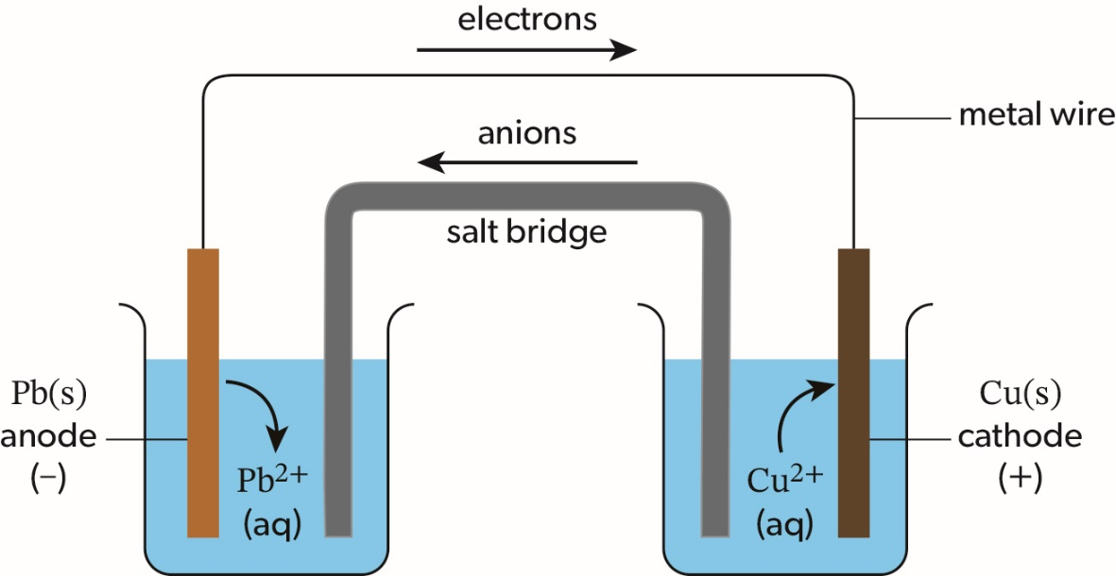
The electrodes can be connected with a metal wire either directly or through a voltmeter (or any other device, such as a light bulb). In addition to the flow of anions, the flow of cations through the salt bridge (from left to right) can also be shown.
  - Pb(s)|Pb²⁺(aq)||Cu²⁺(aq)|Cu(s)
Notice that the cathode must be drawn on the right-hand side.
  - Anode: Pb(s) → Pb²⁺(aq) + 2e⁻
Cathode: Cu²⁺(aq) + 2e⁻ → Cu(s)
Overall: Pb(s) + Cu²⁺(aq) → Pb²⁺(aq) + Cu(s)
  - According to section 19 of the data booklet, $E^⊝ (Cu^(2+) (aq)│Cu(s) )=+0.34 V and$ $E^⊝ (Pb^(2+) (aq)│Pb(s) )=-0.13 V.$ Therefore:
$$E_cell^⊝=+0.34 V-(-0.13 V)= +0.47 V$$
Notice that the overall process in a voltaic cell is always spontaneous, so the $E_cell^⊝$ must be positive.

Step | Oxidizing agent | Reducing agent
1 | O₂(aq) | Mn²⁺(aq)
2 | MnO₂(s) | I⁻(aq)
3 | I₂(aq) | S₂O₃²⁻(aq)
  - In the third equation, n(I₂) = 0.5 × n(I⁻) = 0.5 × 0.00150 mol = 7.50 × 10⁻⁴ mol
In the second equation, n(MnO2) = n(I2) = 7.50 × 10−4 mol
In the first equation, n(O₂) = 0.5 × n(MnO₂) = 0.5 × 7.50 × 10⁻⁴ mol = 3.75 × 10⁻⁴ mol
An alternative solution is based on the electron balance. Each O₂(aq) accepts four electrons while each I⁻(aq) loses one electron, so the ratio of O₂(aq) to I⁻(aq) is 1 : 4. Therefore, n(O₂) = 0.25 × 0.00150 mol = 3.75 × 10⁻⁴ mol
- Cathode: Cu²⁺(aq) + 2e⁻ → Cu(s)
Anode: 2H₂O(l) → O₂(g) + 4H⁺(aq) + 4e⁻
Overall: 2Cu²⁺(aq) + 2H₂O(l) → 2Cu(s) + O₂(g) + 4H⁺(aq)
According to the overall equation, the mole ratio of Cu(s) to O₂(g) is 2 : 1. Therefore:
$$n(Cu)=(5.34 g)/(63.55 g 〖mol〗^(-1) )≈0.0840 mol$$
$$n(O_2 )=(0.0840 mol)/2≈0.0420 mol$$
V(O₂) = 0.0420 mol × 22.7 dm³ mol⁻¹ ≈ 0.953 dm³ = 9.53 × 10⁻⁴ m³

3.3 Electron sharing reactions
- C
- Similarities: In both cases a covalent bond breaks, and the electron pair is no longer shared between two atoms. In both cases, a single molecule (or other species) breaks up into two species. Both processes are endothermic.
Differences: In homolytic fission, the bond breaks symmetrically and the two electrons of the shared pair move in opposite directions, so each atom receives a single electron. In heterolytic fission, the bond breaks non-symmetrically and both electrons of the shared pair move in one direction, so one atom receives both electrons while the other atom receives none. Homolytic fission produces uncharged species (two radicals) while heterolytic fission produces charged species (a cation and an anion).

  - Reaction type: radical substitution (S_{R}). Conditions: UV light or heat.
  - Depending on the reaction temperature, all participating species can be liquid or gaseous. In reaction mechanisms, the states are optional.
Initiation:
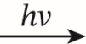
Br₂ 2Br•
Chain propagation:
CH₃CH₃ + Br• → •CH₂CH₃ + HBr
•CH₂CH₃ + Br2 → CH₃CH₂Br + Br•
Chain termination:
•CH₂CH₃ + Br• → CH₃CH₂Br
2Br• → Br₂
2•CH₂CH₃ → CH₃CH₂CH₂CH₃
Notice that the radical dot must be placed on the atom with an unpaired electron (Br or C, but not H).

3.4 Electron-pair sharing reactions
- D
- B

  - The formation of the complex ion, [NiCl₄]²⁻(aq), can be represented as follows:
Ni₂⁺(aq) + 4Cl⁻(aq) ⇌ [NiCl₄]²⁻(aq)
In this reaction, Ni²⁺(aq) acts as a Lewis acid by accepting lone electron pairs from the ligands, Cl⁻(aq). In turn, the ligands act as Lewis bases by donating their lone electron pairs to the nickel(II) ion. Therefore, in terms of the Lewis theory, this reaction can be classified as a neutralization reaction.
  - See part (a). However, notice that the oxidation state of nickel(II) must be written as “+2”, not “2+”.

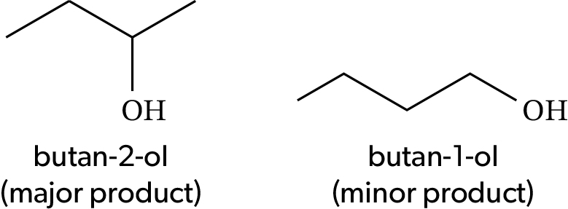
  - Butan-2-ol is the major product because its formation proceeds through the most stable (secondary) carbocation while the formation of butan-1-ol involves a less stable (primary) carbocation.
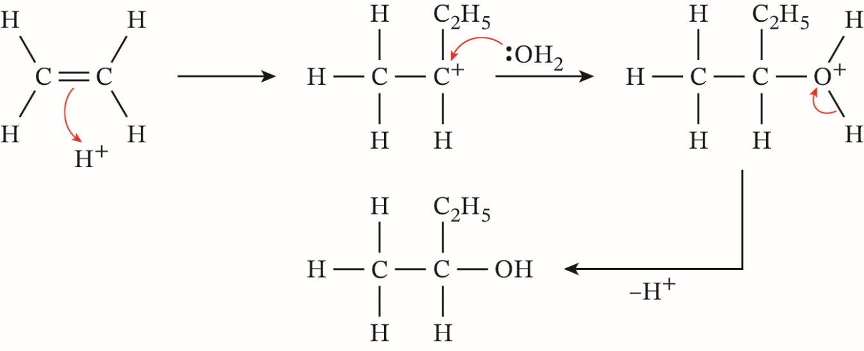
In the last step, the release of H⁺ can be facilitated by a molecule of water, as is shown in the solution to question 5(d) below.

  - (CH₃)₂CBrCH₂CH₃; if the alcohol cannot be oxidized, it must be a tertiary alcohol, so the halogenoalkane must also be tertiary .
  - (CH₃)₂CBrCH₂CH₃ + H₂O → (CH₃)₂C(OH)CH₂CH₃ + HBr
  - S_{N}1, because the halogenoalkane is tertiary, H₂O is a poor nucleophile and Br⁻ is a good leaving group.

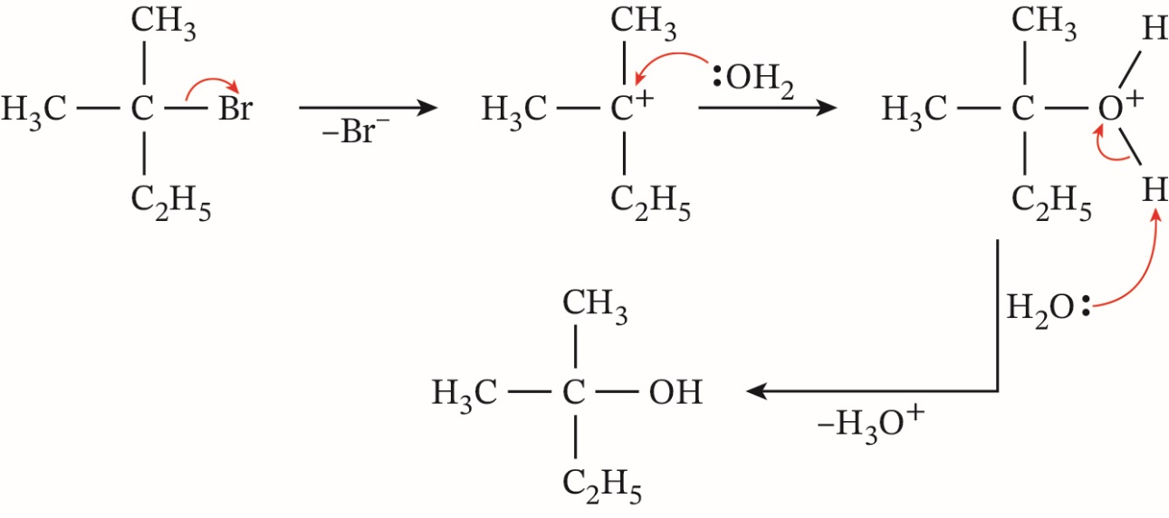
In the last step, Br⁻ can be used instead of H₂O. In that case, the inorganic product will be HBr, as shown in part (b). Notice that in the presence of water, HBr will be fully ionized:
HBr(aq) + H₂O(l) → H₃O⁺(aq) + Br⁻(aq)

  - Aromatic ring (six delocalized electrons that form a ring of high electron density above and below the plane of the six carbon atoms).
  - Nitric acid: the source of nitronium ions, ⁺NO₂, which act as electrophiles in reaction with benzene.
  - Sulfuric acid: the catalyst and dehydrating agent that facilitates the formation of nitronium ions and removes the reaction by-product (water) by converting it into hydronium ions, H₃O⁺.

Tool 1—Experimental techniques
- D

  - flammable
  - corrosive
  - oxidizing
  - explosive
  - toxic
  - serious health hazard
  - compressed gas
  - hazardous to the environment
  - health hazard/harmful/irritant/hazardous to ozone layer
- Digital thermometers can measure temperature with more significant figures (or decimal places) than glass bulb thermometers. In contrast to glass bulb thermometers, the accuracy of digital thermometers can be improved by calibration. Finally, digital thermometers typically have better linearity (i.e. their accuracy and precision do not vary significantly across the whole range of measured temperatures).

  - Analytical balance, beaker, glass/stirring rod, funnel, volumetric flask, pipette, wash bottle, reagent bottle.
  - Burette, funnel, conical flask(s), volumetric pipette, Pasteur pipette (for adding the indicator) or pH probe.
  - Beakers, electrodes, voltmeter (or other electric device), salt bridge, connecting wires.
- Electrons (negative charge carriers) move from the anode (negative electrode) to the cathode (positive electrode) through the external circuit (wire, optionally with a voltmeter or other electric device). Cations (positive charge carriers) move from the anode half-cell to the cathode half-cell through the salt bridge. Anions (negative charge carriers) move from the cathode half-cell to the anode half-cell through the salt bridge.

  - Distillation: excess propan-1-ol is heated with an oxidizing reagent in a distillation apparatus. The vapour of propanal escapes the reaction mixture, passes into the condenser and turns into liquid, which is collected in the receiver flask.
  - Heating under reflux: propan-1-ol is heated with excess oxidizing reagent in a flask equipped with a reflux condenser. The vapour of the intermediate product (propanal) is continuously returned to the reaction mixture, where it is oxidized further to propanoic acid.
- The mixture is spotted on the start line drawn with a pencil and ruler on a piece of chromatographic paper. Pure samples of all three compounds (propan-1-ol, propanal and propanoic acid) are placed as separate spots on the same start line. A sample of the mixture is also placed as a separate spot on the start line. The paper is dipped into an appropriate solvent in a covered beaker, making sure that the solvent level is below the start line. When the solvent front has moved up most of the paper length, the paper is removed from the beaker, the position of the solvent front is marked with a pencil, and the paper is allowed to dry. The spots are revealed either by spraying the paper with a developing reagent or by placing the paper under UV light. The position of spots from the mixture can be compared with those from the three pure compounds.

  - ultraviolet/UV
  - A series of solutions with different concentrations of the analyte (protein) is prepared by serial dilution. The absorption of each sample is measured and plotted against the sample concentration. The best-fit line is drawn through the points on the plot.
  - c = 0.408 mmol dm⁻³, as follows from the plot:
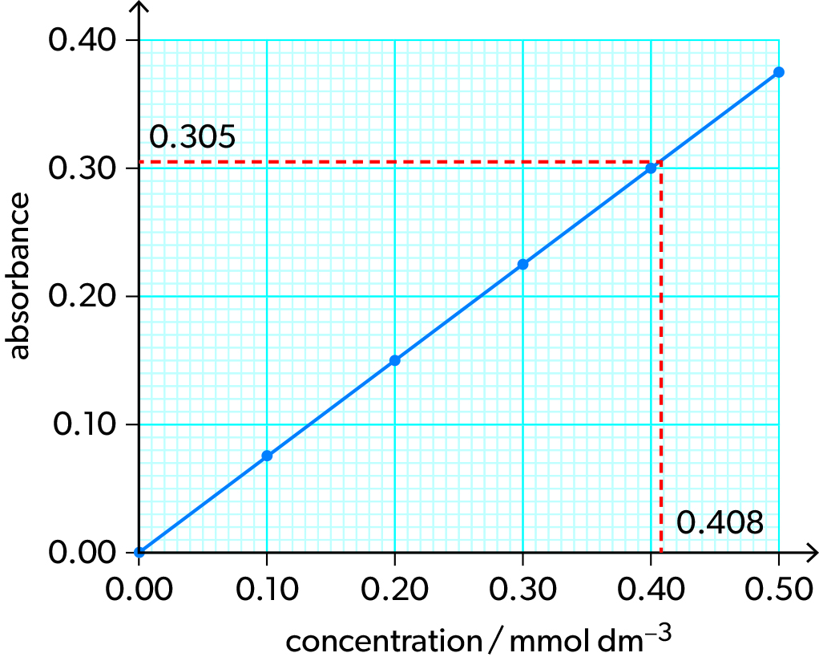
The acceptable range of answers is 0.405–0.410 mmol dm⁻³.

Tool 2—Technology
- A digital pH probe and a digital conductivity probe connected to a data logger or computer. Alternatively, any pH and conductivity probes (digital or analogue) can be used if their readings are recorded continuously using a video camera or a mobile phone.
- Advantages: simple protocol, no specialized laboratory equipment or materials are required, data are recorded automatically, video recordings of experiments can be reviewed later.
Disadvantages: low accuracy and low precision, the results are affected by external lighting, calibration is problematic.
- In addition to the database of your choice, the melting points and boiling points (but not density) of group 1 elements are listed in section 8 of the data booklet.
- Your plots should be similar to figure 9 in Student Book Structure 3.2.

  - The value 8.31 (probably the gas constant, R) is multiplied by the value in cell A1 and divided by the product of values in cells B2 and B3.
  - The sum of the values in cells B1 through B10 is calculated.
  - The average (mean) of the values in cells B2, B3 and B5 is calculated.
- Each model can be constructed in many ways. One example is given for each model using standard Microsoft Excel functions.

  - The concentration of sulfuric acid (in mol dm⁻³) is entered as a numerical value in cell A1, and the solution pH is calculated automatically in any other cell using the following formula:
=-log(A1*2)
Notice that each mole of H₂SO₄(aq) produces two H⁺(aq) ions, hence the coefficient “2” in the formula.
If more than one pair of concentration and pH values must be shown simultaneously, the list of concentrations can be entered in column A, and the formula can be copied to all cells in column B (the cell references will be updated automatically).
In examination papers, you will not be expected to provide Excel expressions. To score full marks, you will only need to mention that the concentration is entered in one cell and the pH is calculated using a reference to that cell and a spreadsheet-specific mathematical expression.
  - The melting points (in °C or K) are entered in column A, the boiling points (in the same units) are entered in column B, and a scatter plot is constructed using the data in these two columns. The best-fit line (trendline) or best-fit curve is drawn using the internal functionality of the spreadsheet software. The R² value and the equation of the best-fit line or curve are calculated by the software and shown on the plot.
  - The concentrations (in mol dm⁻³) of NH₃(g), N₂(g) and H₂(g) are entered in cells A1, A2 and A3, respectively. The value of the equilibrium constant (K) at a given temperature is entered in cell A4. The reaction quotient (Q) is calculated automatically in cell A5 using the following formula:
=A2*A3^3/A1^2
The values of K and Q can be compared either visually or using Boolean operators. For example, the following expression will display the direction of favoured reaction (forward, reverse or neither):
=IF(A5<A4,"forward",IF(A5>A4,"reverse","neither"))
This model can be used to predict the effects of concentrations of NH₃(g), N₂(g) and H₂(g) on the equilibrium position. Similar approaches can be used for modelling the effects of pressure and temperature.

Tool 3—Mathematics
- C
- 2A
- 3C
- 4C
- 5B
- Value:
$rate=|((0.050-0.045 mol 〖dm〗^(-3))/((10.0-25.0) s)|≈3.3×10^(-4)$mol dm⁻³ s⁻¹
Percentage uncertainty:
u(concentration) = ±(0.001 + 0.001) mol dm⁻³ = ±0.002 mol dm⁻³
u(concentration) = $(±0.002 mol 〖dm〗^(-3))/((0.050-0.045) mol 〖dm〗^(-3) )×100\%=±40\%$
u(time) = ±(0.5 + 0.5) s = ±1 s
u%(time) = $(±1 s)/(|10.0-25.0| s)×100\%≈±7\%$
u%(rate) = ±(40% + 7%) = ±47% ≈ 50%
Absolute uncertainty:
u(rate) = 3.3 × 10⁻⁴ mol dm⁻³ s⁻¹ ×$(±50\%)/(100\%)≈$1.7 × 10⁻⁴ mol dm⁻³ s⁻¹
Notice that the rate calculation involves division, so the absolute uncertainty can be calculated only after the percentage uncertainty has been determined.
Also, the percentage uncertainty is very high, so the values of the rate and its absolute uncertainty might be rounded to one significant figure each:
rate = (3 ± 2) × 10⁻⁴ mol dm⁻³ s⁻¹
- Your answer can be based on figure 30 in R3.3 and the paragraph of text before that figure. For example, you can say that the coefficient of determination shows the quality of the correlation: the higher the R² value, the better the line of best fit describes the relationship between the dependent and independent variables.

  - For most reactions, the rate approximately doubles when temperature increases by 10 degrees, so your sketch should show an exponential increase of the rate with temperature:
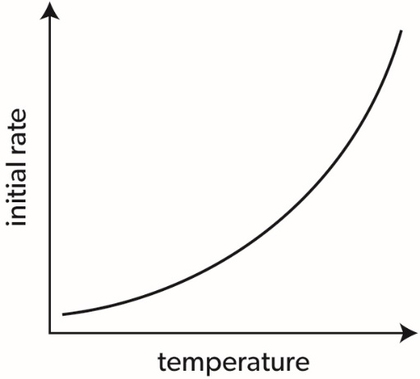
  - The reaction is exothermic ($∆H^⊝$ > 0), so at low temperatures K ≫ 1 and the equilibrium position is shifted almost completely to the right (towards the products). Therefore, the theoretical yield at low temperatures will be close to 100%, and the curve will be almost horizontal.
An increase in temperature will shift the equilibrium position to the left (towards reactants) and thus reduce the theoretical yield of ammonia, so the curve will go down.
At high temperatures, K ≪ 1, so the equilibrium position will be shifted almost completely to the left (towards the reactants). Therefore, the theoretical yield of ammonia will become close to zero, and the curve will flatten again:
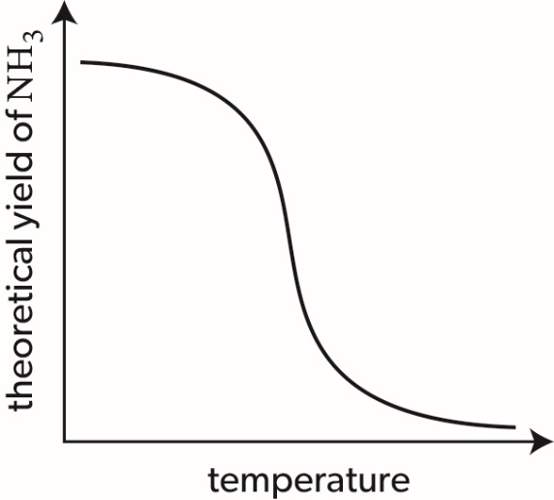
To score full marks, your sketch does not have to show all features of this curve (any decreasing curve or line would be acceptable).
  - An increase in temperature will both increase the reaction rate and shift the equilibrium position to the left. The first effect will increase the practical yield while the second effect will decrease that yield. Initially, the first effect will be dominant (because the rate will increase exponentially). At a certain temperature, the rate will become so high that the equilibrium will be reached almost instantaneously. Any further increase in temperature will reduce the practical yield because the equilibrium position will shift further and further to the left. Therefore, the practical yield will first increase and then decrease, so the resulting curve will look like the curve in part (a) at the beginning and like the curve in part (b) at the end:
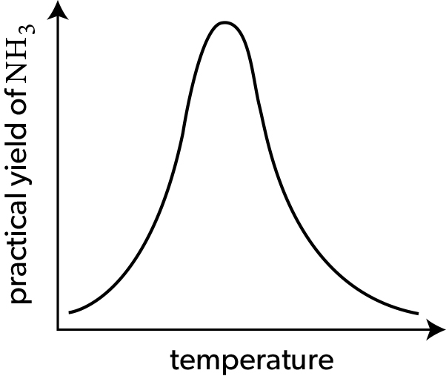
This example demonstrates how technological processes can be optimized: to maximize the practical yield, the synthesis of ammonia must be carried out at a certain temperature (which in turn depends on the pressure and concentrations of the reactants). The optimal reaction conditions (temperature, pressure and concentrations) can be determined using computer modelling and then applied to the actual synthetic procedure.

  - the molar mass (M) of that compound
  - absolute zero (0 K)
  - the initial concentration of that reactant
  - the proportion of unreactive (“cold”) particles in the reaction mixture.

  - table
  - line graph
  - histogram
  - pie chart
  - line graph, bar (column) chart or table.
Notice that the first ionization energies (IE₁) can be represented in several ways, depending on the intended use of these data. A line graph could be used in a textbook to illustrate the general trend of IE₁ values across a period. A bar chart would be more suitable for a lecture or presentation to capture the attention of the audience. A table can be used in a reference book as the most compact and convenient format of quantitative data.

